CHAPTER III
PRODUCT FEATURES

This chapter presents the product features of HydroSense, offering a detailed overview of its various modules and components. It included a decomposition chart that visualized the primary product features and their interconnections. Each module was briefly explained, focusing on user interactions, activity diagrams, and the steps prompted within the web application. Additionally, the chapter listed the functional requirements defined by the developers for each module, ensuring the system goals were met upon development. This comprehensive introduction gave readers a clear understanding of HydroSense capabilities and how they enabled effective water quality monitoring and management.

3.1 Product Decomposition
HydroSense comprised several main functionalities that ensured comprehensive water quality monitoring and management. The interfacing functionality included initial setup, connecting devices to the HydroSense access point, and ensuring Wi-Fi connectivity. For a thorough assessment, water quality analysis used sensors to measure dissolved particles, pH, and suspended particles. This function displayed water quality data and suggested purification methods based on contaminants. It included real-time data visualization, historical trend analysis, and data export. The hydrology resources section offered articles and guides on water safety and purification, enhancing users' understanding and managing water quality. The integration of these functionalities streamlined HydroSense operations, as depicted in Figure 7.

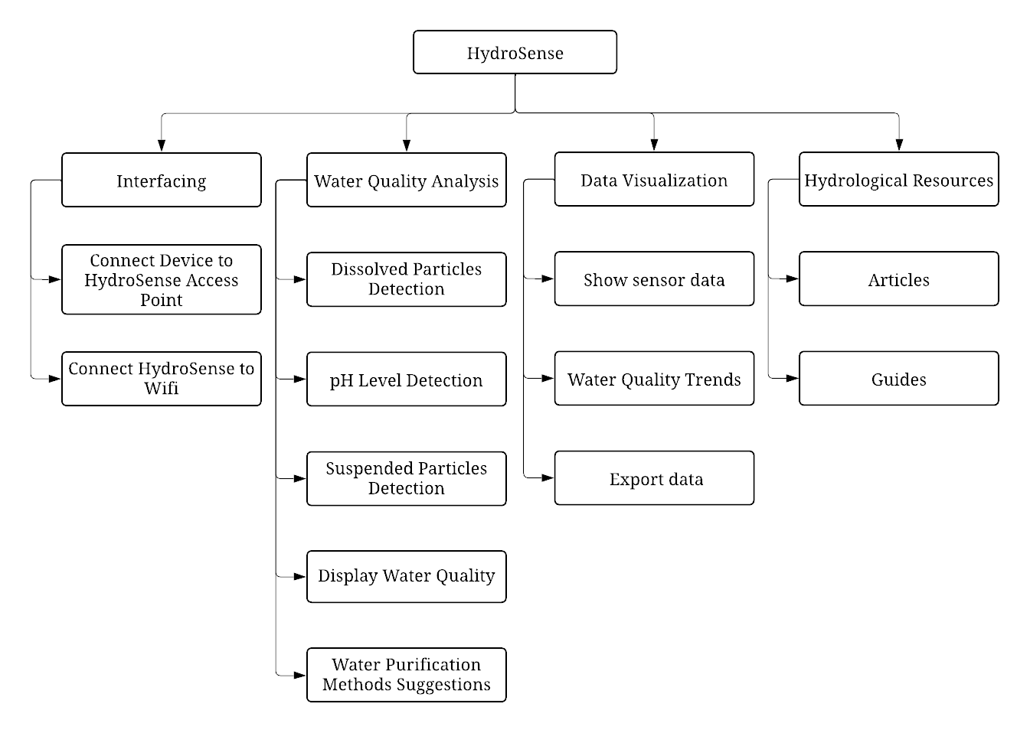
Figure 7. HydroSense Decomposition Chart.

3.2 System Functionalities
The developers provided a detailed explanation of the creation and integration of each module within HydroSense. The following subsections describe how the functionalities operated when users interacted with the web application, detailing the system response based on user actions and the interconnectivity of its modules on the backend. Developers used activity diagrams to illustrate each module data and command flow. Each module description included a list of functional requirements to ensure alignment with overall project goals.
3.2.1 Interfacing
This module handled the initial setup process, including connecting HydroSense to the network and ensuring all devices were paired correctly. Users were guided through the interfacing process via a series of prompts within the web application. Successful interfacing ensured seamless data flow from the sensors to the web application.
3.2.1.1 Description and Priority
To interface was crucial for establishing a reliable connection between HydroSense and the network. Users were required to connect the Arduino to an internet router, connect their device to the same router, and then open the Internet Protocol (IP) address of the Arduino device in a browser. The system checked if the Arduino was connected to Wi-Fi, and the web server interface was displayed upon confirmation. By ensuring the HydroSense system collect and transmit data effectively was a high priority, as it was foundational for the system operation.
3.2.1.2 Stimulus/Response Sequence
Users began interfacing by powering on the HydroSense device and turning on the access point. The device displayed a captive portal. Users connected their devices to the HydroSense access point and entered the Wi-Fi Service Set Identifier (SSID) and password. The system checked if the Wi-Fi SSID and password were correct. If correct, HydroSense connected to Wi-Fi and displayed the web server IP address on the OLED screen. Users then connected their devices to the same Wi-Fi network, opened a web browser, and entered the Internet Protocol (IP) address to access the HydroSense website. An error message prompted the user to re-enter the details if the Wi-Fi name and password were incorrect. This ensured the proper setup and operation of the HydroSense system. Table 12 indicates the sequence of tasks that the user performed for interfacing.

Function Name | Interfacing
Function Description
Precondition | - HydroSense device and access point are powered on.  - User has access to a device connected to the same network as the HydroSense device.
Post Condition | - HydroSense is connected to the WiFi network.  - The web server interface is accessible, allowing data transmission from sensors to the web application.
Activity Flow
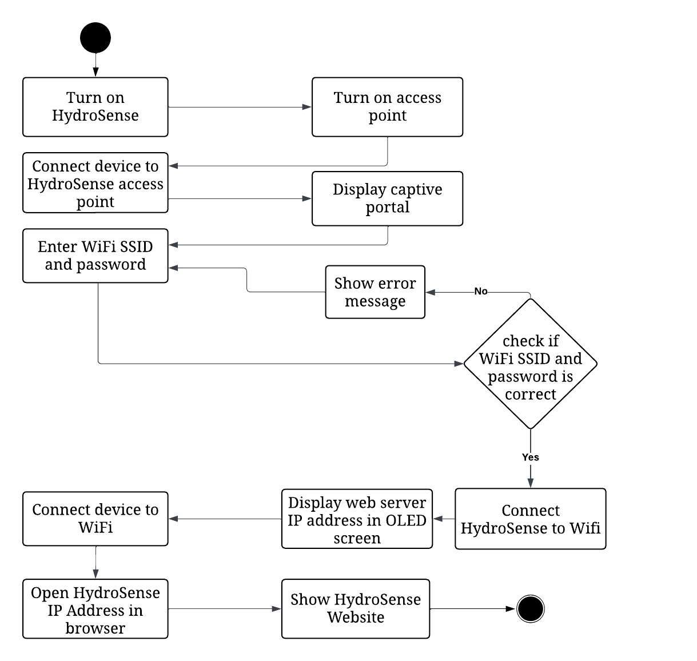  User | HydroSense
Alternate Flow | - The Wi-Fi SSID and password are incorrect.
Exception | - The access point did not turn on.
Table 12. Interfacing Activity Diagram.
      - Functional Requirements
The developers outlined the tasks needed to interface HydroSense with the network and ensure its proper setup. The interfacing process was essential for accurate data collection. Users had to connect the Arduino to the network and access the web server interface, guided by the system to ensure all connections were established. Once connected, users remotely monitor and manage the system through the web interface. Users also had to power on the HydroSense device.
- Users must connect the Arduino to the internet router.
- The system checks if the Arduino is powered on and attempts to establish a network connection.
- Users then connect their device (laptop, smartphone, etc.) to the same internet router.
- The system verifies that the user device is connected to the same network as the Arduino.
- Users open a web browser and enter the IP address of the Arduino device.
- The system checks if the Arduino is connected to Wi-Fi.
- If the Arduino is successfully connected, the system displays the web server interface.
- If the Arduino is not connected to Wi-Fi, the system prompts the user to check the Wi-Fi settings and retry the connection.
- The system ensures that the web server interface is accessible only after a successful interfacing process.
3.2.2 Water Quality Analysis
The water quality analysis system employed sensors to measure various parameters, including TDS, pH, and Turbidity of a water sample. If needed, the system combined these measurements to assess water quality and displayed treatment recommendations. Users easily view both the results and the suggestions, ensuring accurate monitoring and management.
3.2.1.1 Description and Priority
The water quality analysis system was designed to measure and evaluate water quality using sensors that detected TDS, pH levels, and Turbidity. The sensor data was transmitted and combined to comprehensively assess the water condition. The system generated and displayed specific water treatment recommendations based on the data, offering accurate and actionable information on water quality.
3.2.1.2 Stimulus/Response Sequence
The water quality analysis system operated by placing a sensor in a water sample, which initiated the data transmission check. The system measured the TDS, pH level, and Turbidity upon successful data transmission. These measurements were then combined to assess the overall water quality. The system generated and displayed a water treatment recommendation based on the combined data, ensuring users received accurate and actionable information on water quality. Table 13 indicates the sequence of tasks during water quality analysis.

Function Name | Water Quality Analysis
Function Description | This function measures and evaluates the quality of water by using sensors to provide a comprehensive assessment of the water condition and generate treatment recommendations
Precondition | - The sensor is properly connected.  - The water sample is available for testing.
Post Condition | - The system displays the water quality results.  - The system provides water treatment recommendations based on the analysis.
Activity Flow
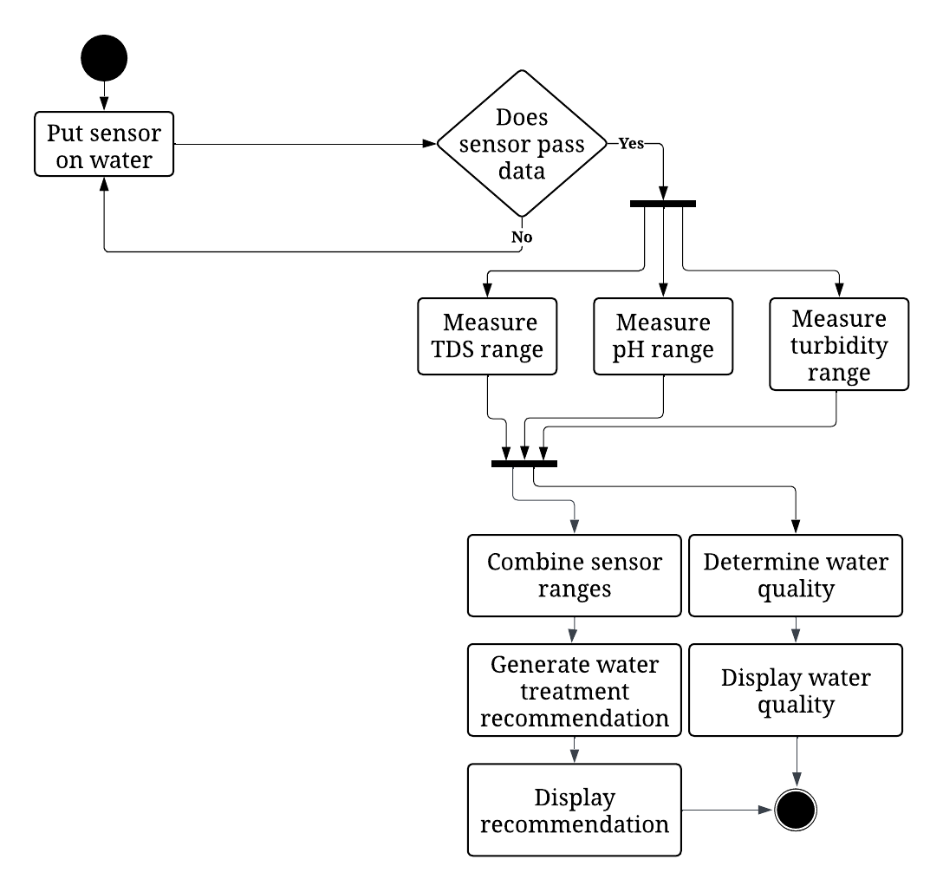  User | HydroSense
Alternative Flow | - Sensor fails to submit data.  - System prompts user to check sensor connection and retry.
Exception | - The sensor does not pass data, the system prompts the user to check the sensor and retry the detection process.
Table 13. Water Quality Analysis Activity Diagram.
3.2.2.3 Functional Requirements
The developers outlined the tasks necessary to function correctly for the water quality analysis process. Users placed the sensor in the water, and the system checked if the sensor was passing data. If data was being passed, the system measured the TDS, pH, and turbidity ranges. The system then combined these measurements to determine the overall water quality and generated a water treatment recommendation for the user. Finally, the system displayed the water quality results and the treatment recommendation to the user, ensuring comprehensive and actionable feedback.
- Users place the sensor in the water to start the detection process.
- The system checks if the sensor is passing data.
- If the sensor passes data, the system measures the TDS range of the water.
- The system measures the pH range of the water.
- The system measures the turbidity range of the water.
- The system combines the sensor measurements to determine the overall water quality.
- The system generates a water treatment recommendation based on the combined data.
- The system displays the determined water quality and the treatment recommendation to the user.
- If the sensor does not pass data, the system prompts the user to check the sensor and retry the detection process.
3.2.3 Data Visualization
The Data Visualization system for water quality analysis was crucial in effectively monitoring and managing water quality. The system-initiated data collection and verified successful data transmission by placing a sensor in the water. Users start and stop data logging through an intuitive interface. The collected data was compiled into a CSV file, providing live and historical views. CSV export enabled easy data download for analysis.
3.2.3.1 Description and Priority
The Data Visualization system for water quality analysis is designed to provide accurate and comprehensive monitoring through real-time data collection and visualization. Developers chose the CSV le format for data export due to its wide compatibility and ease of use with various data analysis tools, ensuring that users seamlessly integrate the collected data into their existing workflows. By visualizing the data is essential for quickly identifying trends and anomalies in water quality, allowing for immediate corrective actions if necessary.
3.2.3.2 Stimulus/Response Sequence
When users placed the sensor in the water, the system checked if data was being transmitted. Upon successful data transmission, users clicked the start logging button, initiating data collection. The system created and populated a CSV le while displaying live data. Users stop logging by clicking the stop logging button, after which they select the export data option. The system allowed users to download the collected data as a CSV file for further analysis. Table 14 shows how data visualization worked.

Function Name | Data Visualization
Function Description | The Data Visualization system for water quality analysis collects, logs, and visualizes data from the sensors. It allows users to view live and historical data and export the data.
Precondition | - The sensor is properly connected.  - The water sample is available for testing.
Post Condition | - The system displays live and historical water quality data.  - The data is logged and saved in a CSV file.  - Users export and download the CSV file containing the collected data.
Activity Flow
User | HydroSense
 | 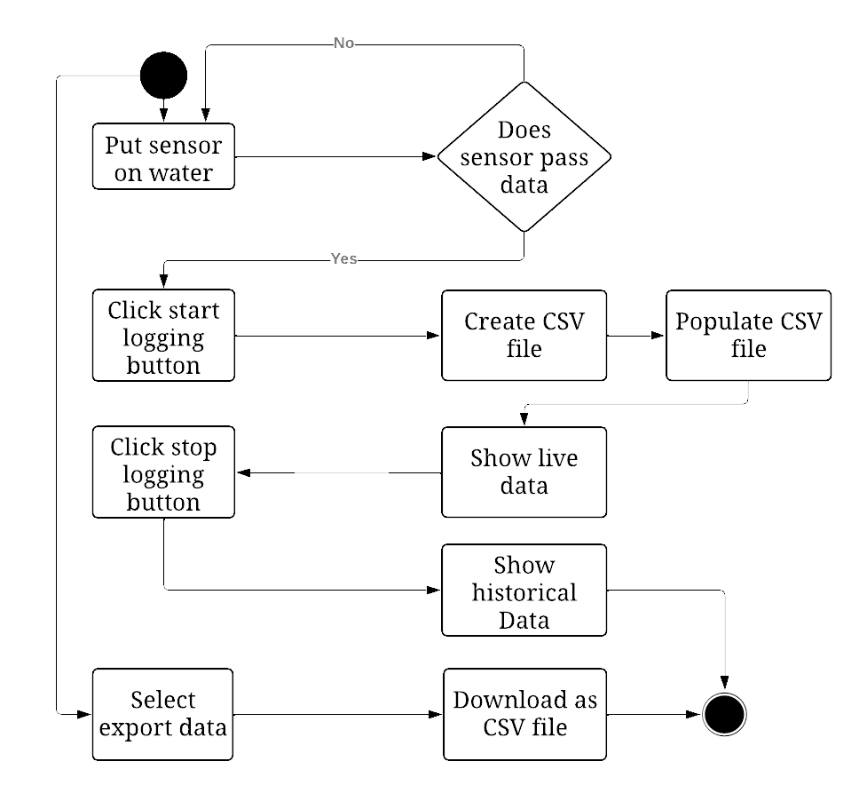
Alternate Flow | - Sensor fails to submit data.  - System prompts user to check sensor connection and retry
Exception | - The sensor does not pass data, the system prompts the user to check the sensor and retry the detection process.
Table 14. Data Visualization Activity Diagram.
      - Functional Requirements
The developers outlined the tasks necessary to function correctly for the data visualization process. Users placed the sensor in the water, and the system checked if the sensor was passing data. If data was being passed, users started and stopped data logging, and the system measured the water quality parameters. The system then created and populated a CSV file displaying live and historical data. Finally, the system allowed users to export the data in CSV format by selecting the export data option.
- The user places the sensor in the water to start the data collection process.
- The system checks if the sensor is passing data.
- If the sensor passes data, the user clicks the start logging button to initiate the data logging.
- The system measures water quality parameters and displays live data.
- The user clicks the stop logging button to stop data collection.
- The system compiles the collected data into a CSV file, providing historical data views.
- The user selects the export data option to download the data as a CSV file.
- If the sensor does not pass data, the system prompts the user to check the sensor and retry the data collection process.
3.2.4 Hydrology Resources
The inclusion of hydrology resources in the water quality analysis system was crucial for providing comprehensive and actionable information to users. These resources offered knowledge on water properties and treatment methods, enhancing user understanding. The system provided treatment recommendations based on suspended, pH, and dissolved particles. Users check water safety, access purification tutorials, and make informed decisions with integrated definitions and content.
3.2.4.1 Description and Priority
The integration of hydrology resources in the water quality analysis system is essential for delivering detailed and practical insights into water quality. These resources provide valuable information on water properties and treatment techniques, aiding users in interpreting sensor data. The system offers accurate recommendations by calculating optimal treatment solutions based on parameters like suspended particles, pH, and dissolved particles. Hydrology resources support effective water quality management through informed actions.
3.2.4.2 Stimulus/Response Sequence
When the user clicked the option to fetch recommendations for suspended particles, pH level, and dissolved particles, the system retrieved the necessary data. It calculated the optimal water treatment formula and provided a tutorial if the water was unsafe. If the water was safe, it showed recommendations and allowed users to access hydrological resources for related content and definitions. Table 15 indicates the tasks that enabled the hydrology resources to be displayed to users.
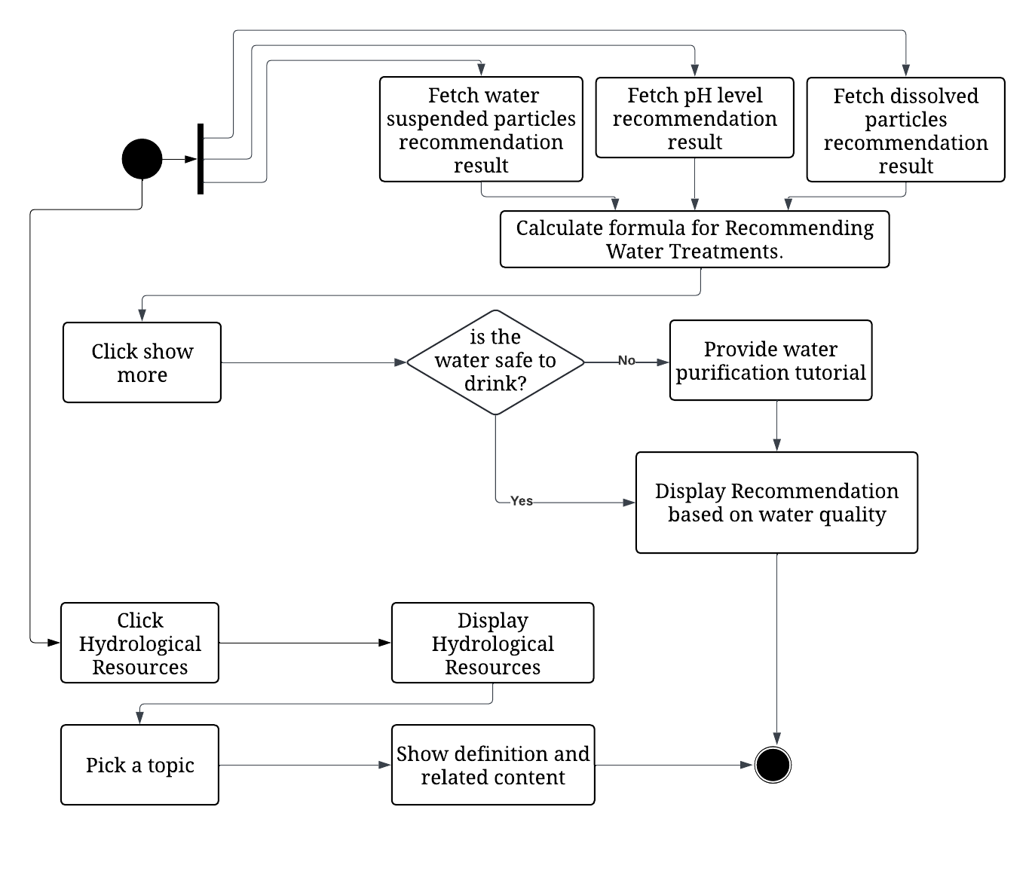
Function Name | Hydrology Resources
Function Description | The hydrology resources provide users with detailed information on water quality, recommended treatment methods and educational resources.
Precondition | - The sensor data is available and accurate.  - The user has access to the hydrology resources interface.
Post Condition | - Hydrology studies and articles are displayed to the user.  - Users are informed about water quality and treatment methods.
Activity Flow
User | HydroSense
Alternate Flow | - Users navigate through various hydrology topics to gain more insights.  - User returns to the previous Page.
Exception | - The system fails to fetch recommendation results.
Table 15. Hydrology Resources Activity Diagram.
      - Functional Requirements
The developers outlined the tasks necessary for the hydrology resources feature in the water quality analysis system to function correctly. The system fetched recommendation results for water-suspended particles, pH levels, and dissolved particles and calculated the optimal formula for recommending water treatments. It determined if the water was safe to drink and, if not, provided a water purification tutorial. Users access hydrological resources to view definitions, related content, and detailed information on various topics by clicking the "learn more about water quality" option. Users access the hydrology resources interface to start the process.
- The system fetches recommendation results for water suspended particles, pH levels, and dissolved particles.
- The system calculates the optimal formula for recommending water treatments.
- The system determines if the water is safe to drink.
- If the water is safe to drink, the system displays a recommendation based on water quality.
- If the water is not safe to drink, the system provides a water purification tutorial.
- Users click “Show More” to access additional information and resources.
- Users click on hydrological resources to display definitions and related content.
- Users select topics within the hydrological resources to view detailed information and definitions.
- If the system fails to fetch recommendation results or if data is incomplete, it notifies the user and provides troubleshooting steps.

This chapter presents the product features of HydroSense, offering a detailed overview of its various modules and components. It included a decomposition chart that visualized the primary product features and their interconnections. Each module was briefly explained, focusing on user interactions, activity diagrams, and the steps prompted within the web application. Additionally, the chapter listed the functional requirements defined by the developers for each module, ensuring the system goals were met upon development. In summary, HydroSense extensive functionalities ensured a comprehensive approach to water quality monitoring and management. Each module, from interfacing and water quality analysis to data visualization and hydrology resources, was designed to provide accurate and actionable insights.

